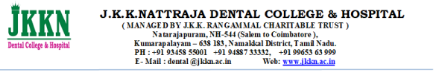

**1.2.2: Average percentage of students enrolled in subject-related Certificate/ Diploma / Add-on courses as against the total number of students during the last five years**

**DETAILED PROGRAM REPORTS OF THE SUBJECT-RELATED**

**ADD-ON COURSES**

| **S.NO** | **DESCRIPTION** | **VIEW DOCUMENTS** |
| --- | --- | --- |
| **1.** | **ACADEMIC YEAR 2023-24** |  |