**DIGITAL RADIOGRAPHY**

Digital radiography refers to a method of capturing a radiographic image using a sensor, breaking it into electronic pieces and presenting and storing the image using a computer. Digital sensors are used instead of radiographic films are used.

**Advantages:**

* Dose reduction upto 50 -90% compared to conventional
* Image can be manipulated
* Contrast of the image can be enhanced
* Measurements can be done
* Images are electronically transferred to other healthcare providers
* It can stored for future use and study purpose
* Environment friendly – avoids chemicals used in processing and lead foil

**Disadvantage:**

* Relatively high initial cost
* Rigid sensor dimensions
* Large disc space is needed to store the data

**Terminologies:**

* Matrix – the image to be taken is represented as many rows and columns
* Pixel – picture element. Each pixel is assigned a value, related to signal intensity. The value stored in a binary form (0,1)
* Pixel having high value represents dark gray shade, whereas low value represents white shade.
* High dose – high value – dark gray shade

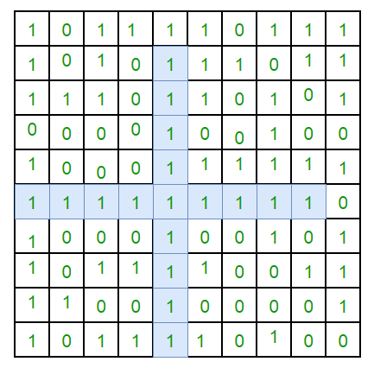

PIXEL

**Methods:**

* Direct - sensor is placed in the patient’s mouth and exposed to radiation. From the sensor the image is transmitted to computer monitor within seconds
* Indirect - an existing X-ray film is digitized using a CCD camera, which scans the image, digitizes or converts the image and displays in computer.
* Storage Phosphor Imaging – A reusable imaging plate coated with phosphors is used. The storage phosphor imaging records diagnostic data on the plates following exposure to the X-ray source and high speed scanner to convert the information to electronic files --- displayed on the computer screen

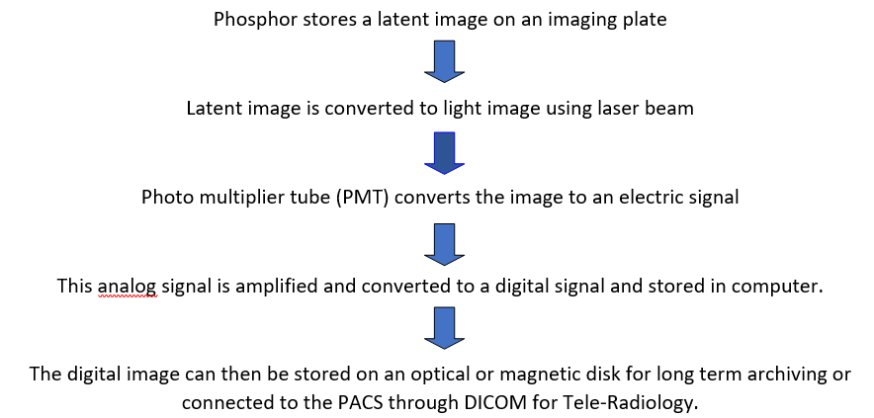

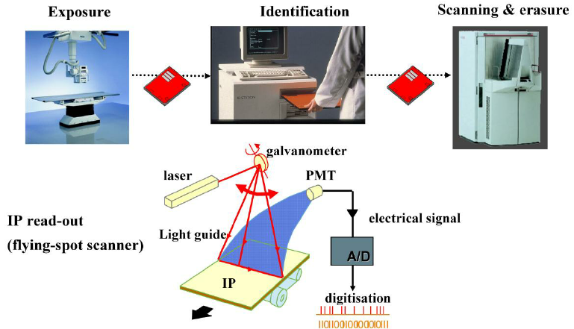

**Components:**

* X-ray generator
* Direct digital sensors
  + Charge coupled device (CCD)
  + Complementary metal oxide semiconductors (CMOS)
  + Photostimulable phosphor plates (PSP)
  + Thin film transistors (TFT)
* Analog to digital converter (ADC)
* Computer
* Monitor or printer for Image display

**Process**

* Image acquisition
* Image processing
* Image display
* Image Archiving
* Image retrieving

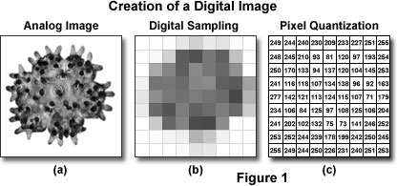

**Types:**

**CHARGE COUPLED DEVICE:**

* First adapted in dentistry in 1987
* It is an integrated circuit made of crystalline silicon
* Forms images from a visible light
* Uses the same radiographic machine as the conventional
* Uses sensors instead of radiographic film to capture
* CCD uses a thin wafer of silicon as the basis for image recording.
* The silicon crystals are formed in a picture element (pixel) matrix.
* When exposed to radiation, the covalent bonds between silicon atoms are broken, producing electron –hole pairs.
* Electrons are the attracted toward the most positive potential in the device, where they create ‘charge packets’

Each packet corresponds to one pixel. The image is read by transferring each row of pixel charges from one pixel to the next in a **bucket brigade** fashion

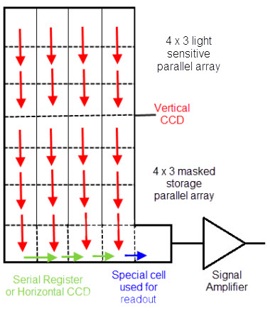

**COMPONENTS:**

|  |  |
| --- | --- |
| **component** | **Function** |
| Scintillator | Convert X-ray into visible light |
| Fiberoptic | Transmit visible light to chip and stop X-rays |
| Main CCD component | Convert light signal to electric voltage |

**PRINCIPLE:**

**RADIOVISIOGRAPHY:**

The latest technology used in Dentistry wit an advantage of dose reduction and time saving.. the principle is same as CCD ..